Appendix 8: SWIFT Qualitative Information Sheet and Consent Form: Clinic Staff
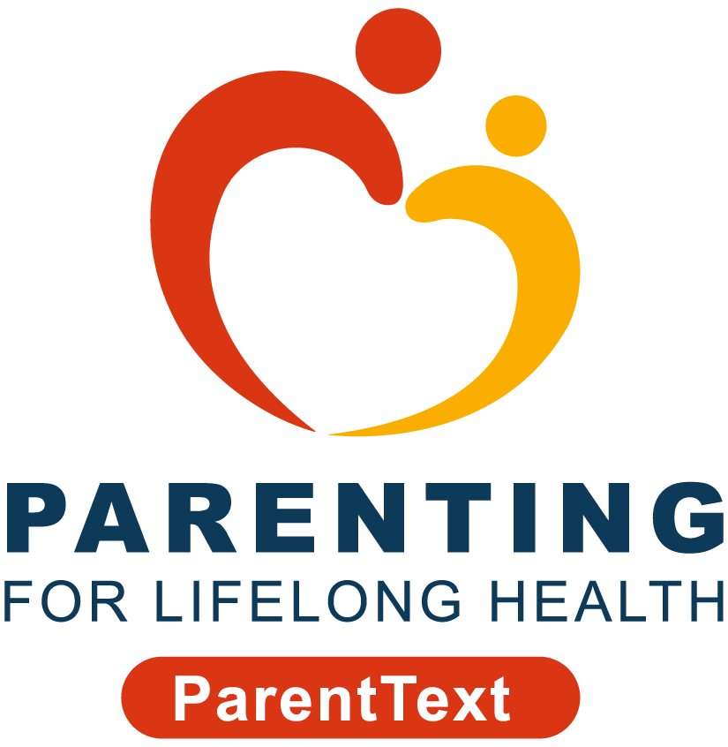



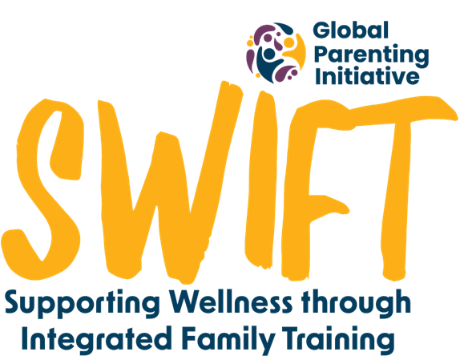


Nurses and clinic staff are playing a pivotal part in our study and we would like to hear about your experiences. This interview is part of a study, carried out by researchers from the Universities of Cape Town in South Africa and the University of Oxford in the United Kingdom.
We want to make sure that you are fully informed before you decide to participate in our study. It’s important for you to know why we’re doing this research and what participating would involve. All the information you might need is outlined below but if you have any questions about your participation or our study, please email the study team at swift@globalparenting.org or message us on WhatsApp at +27 XX XXX XXXX. We’re here to help you!
Why have I been invited to the interview?
Nursing and clinic staff have been integral in the SWIFT study. It has been through the context of your clinic and your daily interaction with parents that the intervention has been delivered. You've been invited to an interview with a member of our research team because you’re part of our study. We would like to hear about your experiences in implementation. To be interviewed, you need to agree to take part in the study.
Do I have to agree to be interviewed?
No, it's up to you if you want to join or not. If you don't want to be interviewed, there will be no implications to you or your job. If you do choose to be interviewed but don't want to answer some questions, you can skip these or stop at any time by telling your interviewer.
What happens if I agree to be interviewed?
If you decide you’d like to be interviewed, you’ll need to agree verbally to the consent questions below which the person interviewing you will ask you. The interviews will happen in person and last between 30-45 minutes. The interviews will be conducted in a private place within the clinics. This interview will be booked ahead of time to ensure that the interviews are not disturbed and cannot be overheard.
During the interview, a member of the research team will ask you some questions about your thoughts and experiences promoting the chatbot to caregivers within the clinic. We want to hear about any feedback you have received from the parents as well as any recommendations you might have for the implementation of the intervention. There are no right or wrong answers because your whole experience is important to us.
To protect your personal information (including your real name, contact details, and any other information that can identify you), we will give you a participant number, and you can choose a name you want us to call you during the interview. Please also do not refer to any other third parties by name during the interview, without their permission, so that we can protect their personal information too.
We will audio record the interview to help us remember the discussion and later write down what was said. The notes we make from the recordings will not include any information that will allow you to be identified, and the data we get from your interview will be linked to you via a confidential identifier. We will delete any personal information we collect from you at the end of the study and, after transcribing your interview, change any data which might lead to identification at the point of transcription.
We may use an artificial intelligence (AI) software, Microsoft Transcriber, to transcribe the interviews at first, and then we will check/review these transcriptions. This AI-generated information will be processed and stored securely on password-protected University of Cape Town servers, and in accordance with POPIA. Only authorised members of the research team will be able to access it, and this data will be owned by the Global Parenting Initiative at the University of Cape Town.
Once the study results are shared, only other colleagues who took part in the study may be able to figure out who you are, based on specific clues provided in your responses. However, we will be interviewing many nurses and clinic staff from at least 7 clinics across two sites in the Western Cape, and we will be carefully watching out for any details you share which may accidentally reveal your identity.
You have the right to request access to your data, to correct any mistakes in your data, and to request us to delete it or transfer it to somewhere else. Please email the study team before [*date to be determined] if you would like to do any of these.
Do I get anything for being interviewed?
You will not be paid for your interview. However, we understand the shortage of time within the clinic setting and so we will provide lunches for the nursing and clinic staff which can be eaten while you are being interviewed.
What happens to my information if I agree to be interviewed?
We only collect what’s needed for the study and store it securely. Your information, like your consent form and interview recording, and any information you provide via email or WhatsApp, will be kept safe on secure servers at the University of Cape Town.
Interview recordings will be deleted after transcription. Any details that identify you will be kept separate and only authorised staff can access them. All data will be kept for five years after the study, but personal information will be deleted when the study ends.
Ethics committees and monitors may check the information. Your information will stay private unless the law says otherwise. After the study, we may share the information with other researchers but without your details. You have the right to see, correct, or ask us to delete your personal information.
What happens to the research results?
What you share with us during your interview will help us understand how best to incorporate the promotion of the chatbot into the everyday business of clinics in the Western Cape, and how to do this without creating a burden on the nursing staff. This chatbot aims to be a support mechanism for parents and a referral avenue for clinic staff.
We also plan to share the results in academic journals, policy briefs and conferences so others can learn from this study too.
Who are some of the study team members?
The principal investigators of this study are Prof Cathy Ward and Cindee Bruyns and the Co-investigator is Carly Katzef all from the University of Cape Town.
Are there any risks in being interviewed?
We don’t expect any risks to you if you are interviewed. If any questions make you uncomfortable, you don’t have to answer them. If you become upset during the interview, you can let your interviewer know. Remember, you can stop participating anytime without giving a reason. We care about your well-being.
We also want to make sure you're safe. If we notice that you, your colleagues or a family you are working with are in serious danger, we might refer you for support or could need to ask for help from other places outside of this study, like social or medical services.
Who pays for the study?
This study is part of the Global Parenting Initiative, funded by the LEGO Foundation, Oak Foundation, the World Childhood Foundation, The Human Safety Net, and the UK Research and Innovation Global Challenges Research Fund.
Data protection
The Universities of Cape Town make sure your personal information is used safely and correctly, just for research. The study follows data protection laws like GDPR (General Data Protection Regulation) in the UK and POPIA (Protection of Personal Information Act) in South Africa. Any data that is transferred across borders will comply with POPIA.
Who has approved this study?
This study has received approval from the University of Cape Town’s Centre for Social Science Research Ethics Committee and University of Cape Town’s Faculty of Health Sciences Human research Ethics Committee. The study has also been approved by the Western Cape Department of Health and Wellness and Department of Social Development, and City of Cape Town’s City health.
Who do I contact if I have questions or concerns?
If you have any questions or concerns about your rights as a study participant, you can contact the study team at swift@globalparenting.org or on WhatsApp at +27 XX XXX XXXX (messages only).
If you have more questions or concerns about your rights, you can contact one of the ethics committees listed:

Name | Telephone | Email
University of Cape Town Centre for Social Science Research | +27 21 650 4656 | cssr@uct.ac.za
Human Research Ethics Committee |  | hrec-enquiries@uct.ac.za







Consent Form: Clinic Staff

[to be signed at the interview]

I ______________________ (participant name) have read the information above and agree to the following:
- I have read the information above and know what I need to do.
- I had time to think about the information and ask questions. I got satisfying answers.
- I know I can say yes or no to being in the study. If I say yes, I can still stop anytime before the [*date to still be determined], without saying why, and without repercussions.
- I am okay with the interview being recorded. I know the recordings will be used for research.
- I know who can see my information, how it will be kept safe, and what happens to it after the study.
- I know I can request access to my data, correct any mistakes, ask to delete it, or for it to be transferred somewhere else.
- I know I won’t be named in any papers or reports from this study.
- I know who to contact if I have a problem with the study.
- I can be contacted again if more information is needed from the study team. I am happy to provide my cell phone number below.
- I understand the team will keep my contact information safe so they can tell me about the results of the study.
I agree with all the statements above and agree to be interviewed for the study, please add your name, signature and the date below.

_____________________ | _____________________ | _____________________
Name of interviewee | Date of Interview | Signature of Interviewee

______________________

Cell phone number of Interviewee

